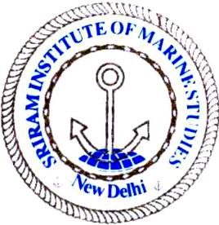 | Sriram Institute of Marine Studies  Approved by the DG Shipping, Ministry of Shipping, Govt. of India. Affiliated to Indian Maritime University Chennai, Certified ISO 9001:2015 By Indian Register of Shipping {IRS} MTI Unique id : 101005
Non Conformance Report

Non Conformance / Observation details: :
{a}.___________________________________________________________________________________________________________________________________________________

{b} _____________________________________________________________________
___________________________________________________________________________
{c} ______________________________________________________________________________________________________________________________________________________

Signature with date: _______________ Auditor’s Signature______________
Name of the auditee:__________________ Name of Auditor:_________________
Date: _________________ Date:____________________________
___________________________________________________________________________
Proposed corrective /preventive action: ______________________________________
___________________________________________________________________________
___________________________________________________________________________

Responsibility : __________________ Audi tee:__________________________

Continue on page 2/-

Continue from pre page 1.

Non conformance closed out : __________________________________________________

{b} _______________________________________________________________________

{c} _______________________________________________________________________

___________________________________________________________________________

Satisfactory/Verified: ________________ ____________________
Date : _____________ Signature
Name:________________
Designation:

