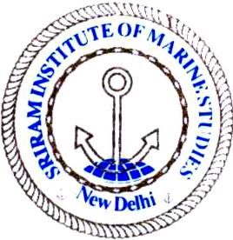 | Sriram Institute of Marine Studies  Approved by the DG Shipping, Ministry of Shipping, Govt. of India. Affiliated to Indian Maritime University Chennai, Certified ISO 9001:2015 By Indian Register of Shipping {IRS} MTI Unique id : 101005
Work Permit to carryout training/operation in Fabrication Shop ____________________________________________________________________________
Date and day____________________ Instructor’s name/Trainer’s name : ______________________________________
Purpose of operation: _____________________________Timing From ____________________ To ________________
Pre operation checks

SNo. | Description of checks conducted | In Order | Deficient | Corrected, if deficient | Remarks
{1} | Work shop visual checks carried out
{2} | All PPEs checked and in order
{3} | All pipelines, valves, checked and working
{4} | All equipment for work in order
{5} | Operator/students are in overall, helmets and apron on.
{6} | Risk assessment & student briefed by the trainer
{7} | All lights, fan, exhaust fan are operational

Verified by instructor and forwarded to course /dept officer for approval : Name ________________________
Signature with date _______________________________ _
I/we are satisfied with the above status of /report and recommend /approve to carry out the work/training :

Course coordinator/ Departmental officer and Submitted to HOI for information
Name and signature with date : ____________________________

